**Eaton’s Best LLC.**

**Statement of Policies & Procedures**

**Purpose & Philosophy on Child Care**

**Our Purpose & Philosophy on Child Care** is respect for each child's individualized pattern and timing of growth, as well as individual personality, learning style, interests, culture, logic and family background are central to the fabric of daily interactions.

**Ages of Children Accepted Into Our Program**

Our afterschool program is dedicated to serving the needs of children ages 5-12. Our summer camps are offered to children ages 5-12 and activities are divided by age groups.

**Services Offered To Special Needs Children**

Children with disabilities have the right to go to school with their neighbors and sit in the classroom together. They can join school clubs, go on field trips, attend school plays, and go to school sports events. Children are not separated because they have a disability.

That being said we are not able to offer our services to children with all types of disabilities. We will meet with parents to discuss the individual needs of the child and determine if our program is a good fit for them.

**Hours & Dates of Operation**

Our afterschool program is in operation Monday through Friday 3:00 PM-5:30PM with the exception of all federally recognized holidays.

We are also open for day camps on all “School Out” days from 7:30 AM – 5:30 PM with the exception of all federally recognized holidays.

Additionally, we provide martial arts training from 5:30 PM-6:30 PM Monday-Thursday for an additional fee.

We may make exceptions to this policy to fit the needs of parents if needed on an individual bases.

**Policy For Adverse Weather & Air Quality Advisories**

As a general rule, if schools are closed for adverse weather and/or air quality advisories, we are also closed.

Our decision to close will be made by 5:00 a.m. on the morning of the closure. Unless an extreme weather alert was issued the night prior for the following day. If conditions worsen during the day and we are forced to close, we will contact you as soon as possible.

Our policy for outdoor air quality advisories is to follow state guidelines for safe outdoor activities. If the air quality index levels exceed 100 all children will be kept indoors until levels return to a sage index.

| **Air Quality Index Levels of Health Concern** | **Numerical Value** | **Meaning** |  |  |
| --- | --- | --- | --- | --- |
| Good | 0 to 50 | Air quality is considered satisfactory, and air pollution poses little or no risk |  |  |
| Moderate | 51 to 100 | Air quality is acceptable; however, for some pollutants there may be a moderate health concern for a very small number of people who are unusually sensitive to air pollution. |  |  |
| Unhealthy for Sensitive Groups | 101 to 150 | Members of sensitive groups may experience health effects. The general public is not likely to be affected. |  |  |
| Unhealthy | 151 to 200 | Everyone may begin to experience health effects; members of sensitive groups may experience more serious health effects. |  |  |
| Very Unhealthy | 201 to 300 | Health alert: everyone may experience more serious health effects |  |  |
| Hazardous | 300 to 500 | Health warnings of emergency conditions. The entire population is more likely to be affected. |  |  |

**Immunization Policy**

As you may have heard, Colorado has new requirements for school and child care-required immunizations.

While a medical exemption for those children who cannot be vaccinated and a nonmedical exemption for those who choose not to vaccinate remains an option for Colorado families, the new law makes the following changes:

* Parents and caregivers claiming a medical exemption from vaccination for their child must have a completed certificate of medical exemption with the signature of a healthcare provider. Medical exemptions only need to be submitted once, unless the student’s information or school changes.
* If a parent or caregiver chooses not to have their child vaccinated, they may claim a nonmedical exemption in one of two ways:
  + Submit the official Certificate of Nonmedical Exemption with the signature of an immunizing provider (such as a medical doctor, advanced practice nurse, pharmacist, etc.) OR
  + Submit the official Certificate of Nonmedical Exemption  received upon completion of CDPHE’s Online Immunization Education Module.

*Note:* Nonmedical exemptions for preschool or child care must be submitted at 2, 4, 6, 12, and 18 months of age. These exemptions expire when the next vaccines are due or when a child enrolls in Kindergarten. Nonmedical exemptions for school-aged children must be submitted annually and expire on June 30th of each year.

* If a student exempts from one or more school-required vaccines for either medical or nonmedical reasons, the appropriate exemption form, as described above, must be on file with their school. The certificate was standardized to include the collection of information necessary in the event of a disease outbreak in our community.
* All immunizing health care providers are required to report both immunizations and exemptions to the Colorado Immunization Information System (CIIS). Parents and caregivers retain the right to opt their child out of CIIS.

**Itemized Fee Schedule**

Registration Fee $47

Yearly Paid-In-Full After School Program Including Day Camps for “Non School Days” $

Yearly After School Program Financed for 42 Weekly Payments of $77/Week

“Non School Days” add on FEE 42 Weekly Payments of $8

Week to Week After School Program is $97/Week

Optional Field Trips $15/day

Optional Snacks Available For $1/Each

Student Should bring one water bottle that can be refilled throughout the day for free. If child does not bring one, a bottle of water will be provided and we will charge $1

Late Pick Up FEE $1/minute

Optional Basic Martial Arts Uniform & White Belt $40

Optional Custom Brazilian Jiu-Jitsu Uniform & Belt $120

Optional “Awesome Kids” T-Shirt $15

Summer Camp Week To Week $37/Day. (Example: 5 day week = $185)

All Weekly Programs Charged On Monday’s, If card is declined for any reason there will be a $15 charge added to amount due.

**Procedure for Identifying Where Children Are At All Times.**

* Sign-in/sign-out sheets

Parents or guardians sign their children in when they arrive and out when they are picked up. The sheet will include the child's name, date, arrival and departure times, and the parent or guardian's signature.

* Staff verification. Each child has an assigned staff member who knows where the child is at all times.

Staff periodically verify attendance throughout the day.

* Sign-out log review

Before staff leave for the day, they review the sign-out log to ensure that all children have been picked up.

* Missing child protocol

If a child is missing, staff will try to locate them and immediately notify the authorities and parent(s) or guardian(s).

We also have a working phone number that is available to the public and to staff at all times. (970-364-6627) The center will post emergency telephone numbers near the phone, including 911, a hospital, and the local police, fire, and health departments.

**Procedure on Positive Guidance, Behavior Expectations, Positive Instruction, Supporting Positive Behaviors, As Well As The Strategies & Techniques For Supporting Children With Challenging Behaviors**

We have a childcare procedure based on positive guidance focuses on setting clear expectations, actively reinforcing positive behaviors, and using supportive strategies to address challenging behaviors, primarily by teaching children what to do rather than focusing on what not to do, while building strong relationships with each child to understand their individual needs and promote healthy development; key strategies include modeling appropriate behavior, providing choices when possible, redirecting negative behaviors, and actively listening to children's concerns.

Our Core Principles of Positive Guidance:

* Focus on the positive:

Highlight and praise desired behaviors, rather than dwelling on negative actions.

* Clear expectations:

Communicate rules and routines in a simple, positive way, ensuring children understand what is expected of them.

* Individualized approach:

Recognize each child's unique needs and adjust strategies accordingly.

* Relationship building:

Foster strong connections with children to better understand their behaviors and provide support.

* Active listening:

Pay attention to children's verbal and nonverbal cues to address underlying concerns.

Our Key Strategies for Positive Instruction and Supporting Positive Behaviors:

* Modeling appropriate behavior:

Demonstrate the desired behavior through your own actions.

* Positive reinforcement:

Use verbal praise, high fives, or other positive rewards to acknowledge good behavior.

* Choice-giving:

Offer children options within reasonable limits to promote autonomy and self-regulation.

* Visual cues:

Utilize visual aids like pictures or charts to support understanding of expectations.

* "I" statements:

Use "I" statements to express concerns in a calm and respectful manner, such as "I feel frustrated when toys are thrown."

* Redirecting behavior:

Gently guide a child towards a more appropriate activity when exhibiting challenging behavior.

Our Strategies for Supporting Children with Challenging Behaviors:

* Identify triggers:

Observe and understand what situations or environmental factors may contribute to challenging behaviors.

* Provide sensory breaks:

Offer calming activities like deep breathing exercises or quiet spaces when needed.

Create a personalized plan with specific strategies tailored to the child's needs.

* Collaborate with parents:

Maintain open communication with parents to discuss concerns and develop consistent approaches at home and in childcare.

* Teach coping skills:

Help children learn strategies to manage their emotions, such as deep breathing, counting, or self-talk.

* Positive time-out:

Provide a designated area for a brief period of calm reflection when necessary, focusing on redirection rather than punishment.

Our Examples of Positive Guidance Phrases:

* "Thank you for sharing your toys!"
* "I see you are using your walking feet inside."
* "Let's try taking turns with the blocks."
* "It looks like you are feeling frustrated, can we talk about what's happening?"
* "You can choose to play with the cars or the dolls."
* We will implement positive guidance strategies consistently across the childcare setting.
* We will Ensure all staff members are well-trained in positive guidance techniques.
* Documentation and observation: We will Regularly monitor children's behavior to identify patterns and adjust strategies as needed.

**Policies & Procedures Concerning Suspension, Expulsion, or Requests To Parent(s) or Guardian(s) To Withdraw A Child From Care Due To Concerns About The Child’s Behavioral Issues.**

We always give a free week trial to make sure the child is a good fit for our program and that our program is a good fit for the child before we charge any money.

If we do not feel it is a good fit at the end of the first week we will seek advice from our mental health consultant and/or at our own discretion notify the parent of our decision to not allow the child to formally enroll the child into the program at that time.

If we find that we have enrolled a child in our program that has behavioral issues that are not consistent with the overall well being of the rest of our children we will contact the parent(s) or guardian(s) and ask for written permission to involve our mental health consultant.

If parent(s) or guardian(s) are unwilling to give permission then the child will be expelled from the program.

If the parent(s) or guardian(s) are willing to give written permission to involve our mental health consultant, we will reach out to our consultant and follow their direction.

If we are unable, through consultations and recommendations with parents and mental health consultant to correct the disruptive behaviors we will expel the student from our program at our own discretion.

**The procedure, including notification of parent(s) or guardian(s), for handling children's illnesses, accidents, and injuries, including when children will be excluded from care and notification of parent(s) or guardian(s).**

* Notification

We will notify parents in writing of all illnesses, accidents, and injuries on the same day they occur, unless the situation requires immediate attention. For accidents, we will give parents enough time to ask questions and understand the situation. We will also provide parents with a copy of the incident report and have them sign it to indicate that they've discussed it.

* Reporting

We will complete an online injury report within 24 hours of an incident. If the online system isn't accessible, we will use a paper form and submit it to the Division of Early Learning and Licensing Administration (DELLA) within 24 hours.

* Local Child Protective Services

We may need to notify local Child Protective Services in certain situations, such as unexplained injuries, injuries that weren't witnessed by an adult, or near drowning.

* Written authority

We will obtain written authority from parents or guardians to arrange for medical care in an emergency.

* Exclusion

State regulations usually specify when children should be excluded from child care. We will consider whether a child's illness prevents them from participating in activities comfortably or if the staff's ability to care for the child would be compromised and notify parent(s) or guardian(s) immediately.

**Our procedures including notification of parent(s) or guardian(s) when a child is separated from their group and is not under the direct supervision of their assigned staff member or for whom the local authorities have been contacted**

When a child is separated from their group and is not under the direct supervision of their assigned staff member, or if local authorities have been contacted, our procedures involve immediately notifying the child's parent(s) or guardian(s) via phone call, followed by a written report documenting the incident, the steps taken to locate the child, and any actions taken by staff to address the situation.

Key elements of the notification process:

* Immediate contact:

Staff will attempt to contact the parent(s) or guardian(s) as soon as possible after discovering the child is missing.

* Detailed information:

The notification will include the child's location, the time of separation, the circumstances surrounding the incident, and the steps being taken to locate the child.

* Follow-up communication:

After initial contact, staff will provide regular updates to the parent(s) or guardian(s) until the child is safely reunited with them.

* Emergency situations:

If the child is missing for an extended period or there are concerns about their safety, emergency services may be contacted in addition to notifying the parents.

* Documentation:

A detailed incident report will be completed, including the time of separation, actions taken by staff to locate the child, who was notified, and any relevant details about the incident.

* Staff training:

All staff will be trained on proper procedures for handling a child who is separated from their group, including how to conduct a search and notify the parent(s) or guardian(s).

**The procedure for transporting children, if applicable, including children’s safety related to riding in a vehicle; seating, supervision, and emergency procedures on the road; transportation arrangements; and parental permission for excursions and related activities**

* Safety

We will Ensure children are safe by using the proper car seats or child restraint systems for their age and weight. If a child needs to use a lap belt, use a child restraint with a built-in harness or a booster seat with the lap belt. We will also teach children to wear seat belts, stay seated, and only get in or out of the vehicle at the curb or an off-street location.

* Supervision

If we are transporting children on a bus, we will plan where we will sit so we can see and hear all children. We will follow the same ratio of monitors to children as teachers to students in the classroom.

* Emergency procedures

We have emergency contact numbers posted near a working telephone, such as 911, a hospital, the fire department, and poison control. The center will also be able to provide emergency transportation to a health care facility.

* Transportation arrangements

We will have a written policy and procedure for transporting children, including transportation arrangements and parental permission for excursions.

* Vehicle maintenance

The vehicle will have a pre-trip inspection before transporting children. The vehicle will also have a annual Inspection, a 2 ½ pound dry chemical file extinguisher, three emergency triangle reflectors, and a 24-unit first aid kit.

**Policy and procedure governing field trips, television and video viewing, and special activities, including the staff’s role for the supervision of children.**

**Policy for media and internet usage.**

Childcare Media and Internet Usage Policy - Screen and Media Use in Curriculum

Purpose: To establish clear guidelines for the appropriate and responsible use of media and technology within the childcare setting, prioritizing educational value and prioritizing children's safety and development, especially regarding online practices for children over four years old.

General Principles:

* Age-Appropriate Content:

All media used will be carefully selected to align with children's developmental stages and interests, prioritizing high-quality educational content.

* Limited Screen Time:

Screen time will be minimized and integrated thoughtfully into the curriculum, with a focus on interactive and engaging activities that promote learning through various modalities.

* Parental Communication:

Parents will be informed about the childcare center's media usage policies and will be encouraged to discuss media use at home with their children.

Media Use for Children Over 4 Years Old:

* Curriculum Integration:

Educational media will be strategically incorporated into the curriculum to reinforce learning concepts, such as educational videos related to science, math, or literacy.

* Digital Literacy Skills:

Children will be introduced to basic digital literacy skills, including navigating simple apps, using a mouse, and understanding basic online safety concepts.

* Online Safety Education:

Regular discussions about online safety practices will occur, including topics like not sharing personal information, being cautious of strangers online, and reporting inappropriate content.

Communication Regarding Online Safety:

* Parent Education:

Parents will receive regular updates on the online safety curriculum being taught to their children, including age-appropriate strategies for discussing online safety at home.

* Direct Instruction:

Teachers will actively incorporate online safety lessons into the curriculum through age-appropriate activities, discussions, and role-playing scenarios.

* Monitoring and Supervision:

Staff will closely monitor children's online activity and provide supervision during any screen time.

Media Selection Criteria:

* Educational Value: Content will align with the curriculum and promote learning goals.
* Age Appropriateness: Content will be suitable for the children's developmental level and interests.
* Positive Role Models: Media will feature positive role models and portray diverse perspectives.
* Quality Production: Content will be well-produced with high-quality visuals and audio.

Review and Revision:

This policy will be reviewed and updated periodically to reflect evolving technology, research on child development, and best practices for online safety.

Note: This policy will be adapted to fit the specific needs and curriculum of our childcare center and be clearly communicated to all staff, parents, and children.

**Procedure for releasing children from the center only to persons for whom the center has written authorization and the procedure for picking-up the child during an emergency.**

Children will ONLY be released from the center to persons for whom the center has written authorization and the procedure for picking-up the child during an emergency.

**Procedures followed when a child is picked up from the center after the closing hours of the center or not picked up at all, and the procedure to ensure that all children are picked up before the staff leave for the day.**

When a child is picked up after closing hours or not picked up at all from a childcare center, the staff will first attempt to contact the parents immediately, then proceed to contact emergency contacts listed on file; if no contact can be made within a reasonable time frame, they will notify the relevant authorities and consider contacting Child Protective Services depending on local regulations; to ensure all children are picked up before staff leave, a thorough check of the sign-out sheet will be conducted, and staff will not leave until all children are accounted for and picked up.

Key steps we follow:

* Immediate contact attempts:
  + Call the parents/guardians directly.
  + Try reaching emergency contacts listed on the child's file.
* Documentation and notification:
  + Record the time of the late pick-up and details of attempts to contact the parents.
  + If no contact is made, document the steps taken and notify the center director or supervisor.
* Late pick-up policy enforcement:
  + Implement a late pick-up fee as outlined in the center's policies.
  + Inform parents of the consequences of repeated late pick-ups.
* Child safety measures:
  + We ensure the child remains under direct supervision until picked up.
  + Provide comfort and reassurance to the child while waiting.
* Contacting authorities:
  + If attempts to contact the parents or emergency contacts are unsuccessful after a reasonable time, contact the appropriate authorities (Child Protective Services in some cases).

Procedure to ensure all children are picked up before staff leave:

* Sign-out check:
  + Before leaving for the day, carefully review the sign-out sheet to verify that all children have been accounted for and picked up.
* Classroom checks:
  + Conduct a thorough check of each classroom to ensure no child is left behind.
* Staff communication:
  + All staff members will be aware of the pick-up procedures and responsible for ensuring all children are accounted for.

* Staff training: All staff are trained on proper procedures for late pick-ups and child safety protocols.

**The procedure for caring for children who arrive late to the center and their class/group is away from the center on a field trip or excursion**

When a child arrives late to a childcare center while their class is on a field trip, the staff will immediately contact the field trip leader to inform them of the late arrival, securely transition the child to a designated staff member who will then safely transport them to the field trip location, ensuring the child is properly supervised and accounted for until they join the group; this may involve coordinating with the transportation provider if necessary to meet the child at a designated location.

Key steps in this procedure:

* Receive the late arrival:

Upon the child's arrival, greet them and confirm their identity.

* Contact the field trip leader:

Immediately call or text the person leading the field trip to inform them about the late arrival and get instructions on where to meet the child.

* Secure the child:

Assign a designated staff member to stay with the child until they are transported to the field trip location.

* Safe transportation:

Arrange for transportation to the field trip location, whether it's by staff vehicle or coordinating with the transportation provider already used for the group.

* Meet the group:

Ensure the staff member accompanying the late child meets the field trip leader at a designated rendezvous point to hand over the child.

* Communication with parents:

Inform the parents of the late arrival and the steps taken to get the child to the field trip location.

Important considerations:

* Child safety:

Prioritize the child's safety by ensuring they are always supervised and accounted for during the transition process.

* Clear communication:

Maintain clear and timely communication with the field trip leader to avoid confusion.

**If child is transported to center by parent, and center is not open, and staff is not at center to receive the child, the child shall not be dropped off by parent. Parent shall deliver the child to the location of the group and properly check child in with staff.**

**Our procedure for storing and administering children's medications and delegation of medication administration in compliance with section 12-255-131, C.R.S., of the “Nurse and Nurse Aide Practice Act.”**

* Storage

We will Keep medications in a locked cupboard or container that's out of reach of children. Store medications in a cool, dry place away from heat, air, light, and moisture. If a medication requires refrigeration, we store it in the refrigerator. Keep medications in their original child-resistant containers, or in other child-resistant containers if necessary. Ensure all containers have unaltered labels.

* Administration

We will Give small amounts of medicine at a time to avoid choking. Let the child swallow all the medicine before giving more.

* Record keeping

We will Keep records of the child's name and date of birth, the name, formulation, and strength of the medicine, how often the medicine should be taken, and how the medicine is taken.

* Delegation

A licensed practical nurse, registered nurse, advanced practice registered nurse, or licensed health care consultant will task to another individual. The delegator should ensure the delegatee can perform the task with the expected degree of care and skill.

**The procedure concerning children's personal belongings and money**

All children will have a cubby assigned to them labeled with the child’s name to store backpacks with personal belongings and money.

Children will only be permitted to access the cubby under staff supervision at designated times.

**The policy concerning meals and snacks**

The child should bring their own lunch and/or snacks. If the child does not bring snacks they can purchase snacks for $1 each.

If the child does not have lunch or snacks we will supply them with what they require and notify parents.

If we are on a field trip or excursion the parents will be notified in advance to pack any additional food.

**The policy and procedure regarding visitors.**

Our Childcare policies and procedures for visitors include:

* Screening

Visitors will need to provide proof of identity, such as a badge or ID, and will need to wait to be confirmed by staff before entering.

* Supervision

Visitors will be supervised by staff at all times, and children will never be left alone with a visitor.

* Communication

Visitors will be informed of any relevant risks to their health and safety.

* Documentation

A record of visitors will be kept, including their names, arrival and departure times, and signatures. This record will be available to parents upon request.

* Identification

Visitors will wear a badge to identify themselves to staff and parents.

* Release

Children will only be released to people listed on the enrollment form, or to people with written and verbal confirmation from a parent.

* Alcohol and drugs

Visitors who appear to be under the influence of drugs or alcohol will not be allowed to pick up a child.

* Court orders

If there is a court order restricting parental contact, the childcare provider will follow the order.

**The procedure for filing a complaint about child care including the name, address, and telephone number of the Colorado Department of Early Childhood (see rule section 2.125 of the General Rules for Child Care Facilities).**

To file a complaint about child care in Colorado, contact the Colorado Department of Early Childhood by calling (303) 866-5958; you can also mail a written complaint with your contact information to their address: 710 S. Ash St, Denver, CO 80246.

Key points to remember:

* Contact number: (303) 866-5958
* Address: 710 S. Ash St, Denver, CO 80246
* Important details to include in your complaint: Name of the child care facility, details of the complaint, date and time of the incident, and your contact information.

**Our procedure for reporting child abuse and/or neglect, including the name of the county Department of Social/Human Services and phone number of where a child abuse report should be made (see section 2.126 of the General Rules for Child Care Facilities). (C.24)**

If we suspect child abuse or neglect, we are required by law to report it immediately. We will report suspected child abuse by calling "Colorado Child Abuse and Neglect Hotline" at 1-844-CO-4-KIDS (1-844-264-5437)

Key points about reporting child abuse in Colorado:

* Phone number: 1-844-CO-4-KIDS
* Any individual who suspects child abuse or neglect is required by law to report it.
* Information to provide: When reporting, be prepared to provide details about the child, the alleged abuser, the nature of the abuse, and any other relevant information.

**Our policy for notification when child care service is withdrawn by the program, or when parent(s) or guardian(s) withdraw their child(ren) from the center.**

Our standard policy for notifying when our childcare program withdraws services or when parents/guardians withdraw their child requires a written notice, with a minimum of two weeks' advance notice, stating the intended withdrawal date; this can be delivered in person, via email, or through a designated withdrawal form.

* Written notice:

Both the childcare center and parents/guardians must provide written notification to formally withdraw services or a child's enrollment.

* Notice period:

We require a minimum of two weeks' notice for withdrawal.

* Reason for withdrawal:

We will ask you to provide a brief explanation for the decision.

* Final payment responsibility:

Parents/guardians are responsible for any outstanding fees up to the last day of attendance.

Specific situations where a childcare center might withdraw services:

* Non-payment of fees: If a family consistently fails to pay their childcare fees.
* Behavioral issues: If a child's behavior significantly disrupts the classroom environment and poses safety concerns.
* Capacity limitations: If the center needs to reduce enrollment due to staffing or facility issues.

**Our procedure for transporting children between school or community-sponsored activities**

* 1. The Transportation Agreement will be discussed and signed by caregiver(s) upon enrollment in program.

**EMERGENCY EVACUATION PROCEDURES**

EMERGENCY GO-KITS WILL BE TAKEN

**EATON’S BEST LLC. EVACUATION LOCATIONS**

Emergency Evacuation Location #1, within walking distance of the child care facility:

Eaton Public Library

Name, address, and telephone number of evacuation location #1:

Eaton Public Library

132 Maple Ave, Eaton CO

970-454-2189

**Walking directions from the child care facility to evacuation location #1:**

START AT EATON’S BEST, WALK SOUTH FROM FRONT EXIT TO 2ND STREET THEN WALK WEST ONE BLOCK TO POST OFFICE

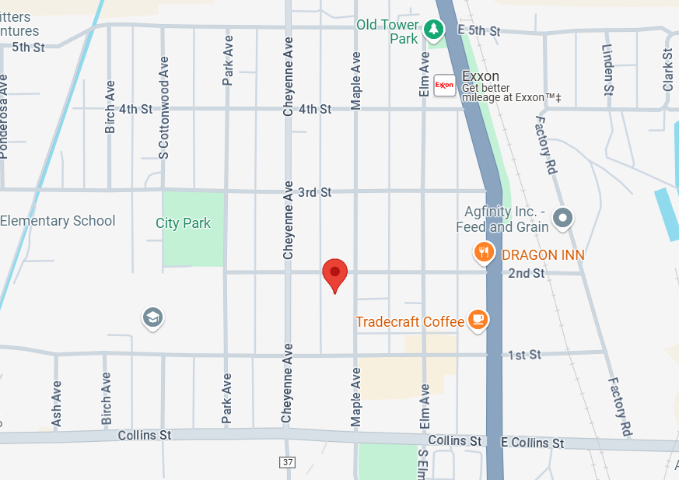

**Alternate walking directions to evacuation location #1:**

START AT EATON’S BEST, WALK SOUTH FROM REAR EXIT TO 2ND STREET THEN WALK WEST ONE BLOCK TO POST OFFICE



**Emergency Evacuation Location #2**

facility: EATON RECREATION CENTER

Name, address, and telephone number of evacuation location #2:

EATON RECREATION CENTER

1675 3RD STREET

EATON, CO 80615

970-454-1070

Driving directions from the child care facility to evacuation location #2

DRIVE NORTH TO 3RD STREET, DRIVE WEST ON 3RD STREET UNTIL YOU ARRIVE

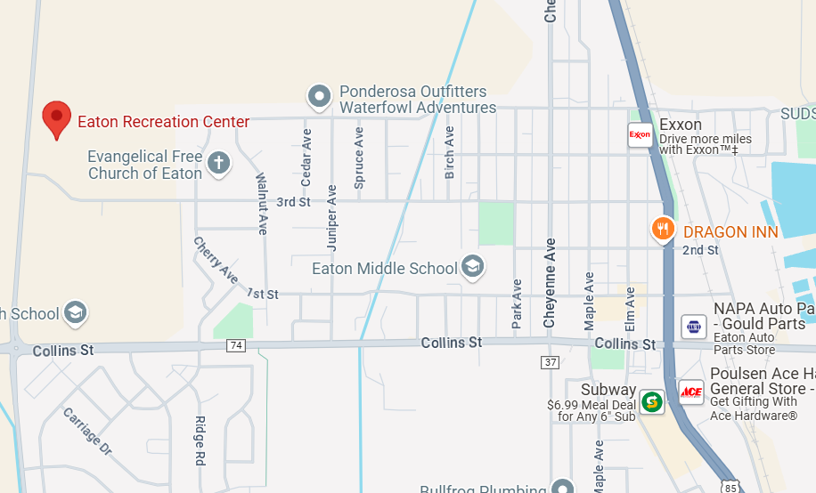

**Alternate driving directions to evacuation location #2:**

DRIVE SOUTH ON HIGHWAY 85 TO COLLINS STREET, THEN WEST ON COLLINS STREET TO COUNTY ROAD 35, THEN DRIVE NORTH ON COUNTY RD 35 TO EATON RECREATION CENTER.



**Emergency Evacuation Location #3:**

HIGHLAND ELEMENTARY SCHOOL

210 WEST 1ST STREET

AULT, CO 80610

970-834-1345

Driving directions from the child care facility to evacuation location #3

DRIVE NORTH ON HIGHWAY 85 TO 1ST STREET IN AULT, CO THEN TURN WEST ON 1ST STREET AND PROCEED TO AULT ELEMENTARY SCHOOL ON LEFT SIDE OF STREET.

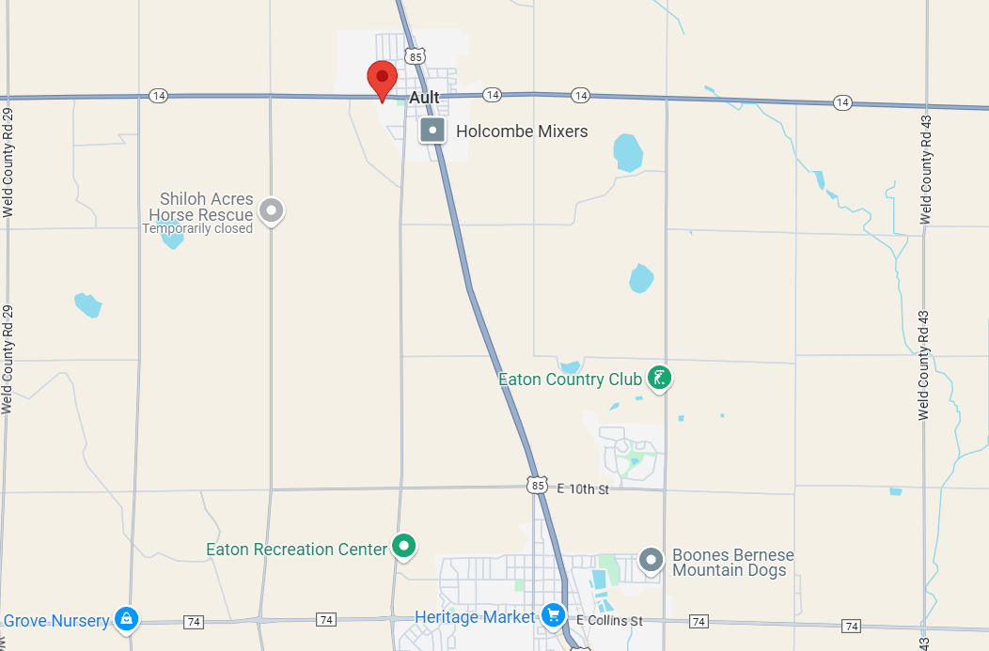

**Alternate driving directions to evacuation location #3:**

DRIVE SOUTH ON HIGHWAY 85 TO COLLINS STREET, THEN TURN WEST ON COLLINS STREET AND DRIVE WEST TO COUNTY ROAD 35, DRIVE NORTH ON COUNTY ROAD 35 TO 1ST STREET IN AULT, TURN WEST ON 1ST STREET, ARRIVE AT 208 1ST STREET.



**ONCE ALL CHILDREN ARE EVACUATED:**

* 911 WILL BE CALLED
* PARENTS WILL BE NOTIFIED

**SHELTER IN PROCEDURES**

IN CASE OF THE NEED TO STAY PUT DUE TO A TORNADO OR NOTIFICATION FROM AUTHORITIES, THE FOLLOWING PROCEEDURES WILL BE FOLLOWED.

* CHILDREN WILL BE TAKEN TO AN INTERIOR ROOM
* A FIRST AID KIT WILL BE AVAILABLE
* CELL PHONE AND PORTABLE CHARGER WILL BE TAKEN
* EMERGENCY CONTACT SHEETS WILL BE KEPT WITH SUPPLIES
* PARENTS/GUARDIANS WILL BE NOTIFIED ONCE THE IMMEDIATE THREAT HAS PASSED

**PARENT REUNIFICATION**

IN CASE OF THE NEED TO EVACUATE OR WHEN PARENTS/GUARDIANS ARE TO UNABLE TO GET CHILDREN, THE FOLLOWING PROCEDURES WILL BE FOLLOWED TO REUNITE CHILDREN WITH PARENTS/GUARDIANS AS SOON AS IT IS SAFE.

CHILDREN WILL ONLY BE RELEASED TO CONTACTS LISTED ON THE CHILD’S FORM WITH PROPER IDENTIFICATION.